Health check
First things to address with health
- Comprehensive Blood testing - this allows us to focus our testing and determine what the overall plan of attack is for healing and optimal function
- Supportive testing - here is our Cyrex testing (food allergies), heavy metal testing, nutritional deficiencies and anything else that can allow us to pinpoint how to better allow the body to heal and be able to sustain professional athletic endeavors for years to come
- Optimal nutritional support and recovery strategies - this is what I sent to you in regards of optimal sleep, optimal hydration, body monitoring with whoop and the initiation of no processed sugar, no gluten diet.
The combination of the above allows us to determine a time scale of how soon we should see symptom improvement and specifically what things are pertinent for you to obtain good healing.
Results
- Comprehensive Blood testing
  - Key findings:
    - Anemia (type is Normocytic Normochromic)
    - Negative Rheumatoid Factor
    - Positive ANA test (Suggestive of Autoimmune disease- Titer is 1:80, Pattern is Nuclear, Dense and fine speckled) - will expand on this below
  - Findings are listed in order of importance above:
    - Anemia is the most important focus for us right now. Extremely simplified -Anemia just means less Red Blood Cells in the blood than there should be. This means that even if your body is getting an adequate diet to fuel your energy, your body isn’t getting enough oxygen to all your tissues to help heal. The further away from the heart, the less oxygen you get. So the first place you would notice the issue's healing would be hands and feet. So we must fix this first b/c without proper oxygen you will not be able to heal. The great news about this is the type of anemia you have which I listed above is Normocytic Normochromic. It’s a fancy way of saying that your red blood cell is the correct size and the correct color, which means it functions well. So we don’t have to add any extra nutrients to drastically help. This is an issue of long standing or chronic inflammation. So the athletes I’ve had in the past that start eating a clean diet (no processed sugars, no gluten, lots of healthy fats/proteins) typically can make a big impact on the anemia in 6 months. This also explains why maybe the healing or feeling completely better has been going slow whereas before it might have just gone away easier. This is likely a new development that’s happened over the last few years. The big take aways are that it is more challenging for your body when you are at high altitude. When you go up to area’s of high elevation (mountains especially) the air is thin, so there is less oxygen. Therefore to make up for this your body produces more red blood cells to help you get the extra oxygen you need to perform and heal. I’m suspicious about the time in the mountains on the break with lots of little sleep and less than ideal food/drinks as the time where you finally noticed it just because of this factor. Your trip didn’t cause this to happen so don’t worry, I’m meaning now it makes sense as to why your trip is really when it triggered.
      - What to do:
        - For the next year - be careful when at high altitude that you get adequate sleep, more water than normal and you are very careful with bad food/drinks.
        - You don’t have to be perfect but just when you extremely tired, then make sure you get lots of water and good food. If you get good sleep but drink alcohol then you eat very good food with lots of water.
        - You continue to eat the way you have for at least another 6 months. I think it will need to be 1 year. This way we can really try to get your red blood cells back to normal. Even if it doesn’t go all the way back it’s okay. We just want as close as possible. You’ll notice in the blood work there are 3 things - Red blood cells, hemoglobin and hematocrit that are Lab Low. Any of these things being indicate anemia. Our goal is to get 1 of them back to normal at our 6 month check on the blood values.
      - Goal - Retest these markers in 6 months from this test (December 2024)
      - Things to discuss - Hyperbaric chamber therapy as a means to help get extra oxygen in the body for healing
    - Negative Rheumatoid Factor - excellent, although these can be negative now and positive later, when I see the ANA or other tests positive this confirms for me that we are not dealing with any Rheumatoid related arthritis (still could be Psoriatic Arthritis but this is much better than Rheumatoid even if that were the case).
    - Positive ANA test - you will see a lot of words above for this test and it’s a confusing one even for doctors. So an ANA test is an Anti-Nuclear Antibody test. These are basically fighters that attack the center of a cell called the nucleus. That’s where the DNA is. If your body is fighting bacteria or a virus when you are sick it’s great but if there are more than usual numbers of these fighters going around that can mean your immune system is overactive which indicates it might be attacking your own bodies tissue. If they see elevated levels it triggers what is called a Titer test which just further measures how many of the ANA’s are in the blood. Yours was 1:80. Think of it like sugar in water (they keep adding water until they can’t find the sugar anymore). So for you they had to dilute your blood with 80 drops of water to get a negative test. So the low level antibodies are anywhere from 1:40-1:80 which means you could be just starting to develop an autoimmune disease or your immune system is a little out of control. >1:180 means you have an autoimmune disease or your immune system is very out of control. You’re right at the border of this. So I still think this is okay. Let me tell you about the next part of the test to explain why it’s okay. The pattern is what they look at next. By the pattern they can differentiate between a lot of the autoimmune diseases but it still might not give a clear picture. Your pattern is nuclear, dense and fine speckled. This could indicate a few different autoimmune things - psoriatic arthritis. I think your case probably falls into 1 of 2 categories. I will include a paper so you can read it more. However, let me tell you why I think it’s still okay. 30% of normal people have a positive ANA meaning high level of fighters. The titer test is still on the borderline of low level antibodies and the pattern you have is the one pattern found in everyday people that test positive and never develop symptoms. So since you have developed symptoms I’ll link the 2 categories I think this leans to so you can understand what I’m thinking and be educated on it. If I had to put anyone in the positive ANA group you are in the one I would take and I actually have tested positive for this exact pattern (when I mentioned to you previously that I’ve had a positive ANA off and on before).
      - Link for categories you fit in - Number 7 and 8 in the list https://www.ncbi.nlm.nih.gov/pmc/articles/PMC10521372/
      - What to do
        - You continue to eat the way you have for 1 year before you start to add anything back in. This way we can get your inflammation down, get your gut in better shape which will help get your immune system under control.
        - You really need to prioritize meditation for 20 minutes each day. What is shown through research is 20 minutes, 2x per day. But I will blow someone’s head off if I sit quietly for that long. The goal is this though - find a program you like.
          - Calm app (I think you mentioned this to me)
          - Mindspace (I’ve used this before)
          - Binaural beats (search this on Spotify or YouTube - it is a frequency that relaxes your brain)
          - Do something guided for 20 minutes per day. Then relaxing music you like or binaural beats -20 minutes each day as well. You have to get active rest daily which means allowing your system to de stress. Imagine it like a cool down lap. If you don’t allow your body to rest some you will stress it too much with how you think/analyze everything. This will keep the immune system bad and it will make your stomach hurt too.
      - Goal - Continue to monitor. Retest ANA blood work above in 6 months. I don’t expect any change, but it is cheap enough and an excellent marker. If we see positive progress by then we know we are on a great track and can adjust the timeline. Try to build 40 minutes into your day for active rest - 20 min meditating and 20 min relaxed music. Every time you relax releases the chemicals needed to relax your immune system.
      - Things to discuss -
        - Earthing.com - grounding mats or bed sheet for sleeping at night
- Supportive testing - Cyrex, Anti-DFS70 (can be a reliable marker for further risk of developing issues related to the inflammatory pain)
  - We have enough really good data here with this first comprehensive panel that I don’t think the huge Cyrex tests that cost $2k are in order. We really just need the basic food related ones so that we can identify how the stomach is doing (is there anything else we can do to support it), then which gluten free foods or other foods are causing inflammation for you. This will be a huge boost of info regardless of what shows up.
  - Anti- DFS70 (https://www.ncbi.nlm.nih.gov/pmc/articles/PMC8468616/) - I am going to try and find this test from a laboratory that will do it - I need to call a few places to find out if I can get them to do it. It would be beneficial b/c it can possibly give us a good 5 year outlook on if we can expect this inflammation to progress so that we know whether you can slowly add in other foods.
- Optimal nutritional support and recovery strategies
  - You are already doing all of it there are 3 things we should talk more in depth about at some point. Maybe when you are in LA
    - Hyperbaric chambers
    - Grounding Sheets/mats
    - PEMP mats
Results of Supportive Testing
- Goal - identify anything that could still be stressing the immune system and identify the best way to calm it down
- Cyrex food allergy results
  - Array 2: Gut barrier inflammation
    - Moderate inflammation from Gap Junction weakness —> Reduce stress, heal gut with glutamine powder.
  - Array 3: Gluten allergy testing
    - Non-Celiac Gluten Sensitivity —> Continue to avoid gluten until symptoms are controlled
  - Array 4: Gluten free allergy testing
    - No allergies to gluten free alternatives, dairy, eggs, etc (full list provided below in Cyrex 4 result)
  - Array 10: Other food’s allergy testing
    - Allergy to Hazelnut and Soy Bean Agglutinin —> Avoid hazelnut and soy products (soy bean and soy sauce)
- Genova Adrenal Test
    - High Cortisol, Low DHEA - impaired stress response leading to immune dysfunction
      - Really work on stress mitigation factors - meditation and other relaxation techniques
Overall impressions
- Stress and relaxation techniques are of HIGH importance
  - Meditation is a must now
  - Really try to maximize travel schedule (ie. Arrive at least one day before, minimize extreme travel when possible (traveling overseas for a 2 or 3 days and back).
  - Eat while sitting down and relaxed (sitting and relaxed is crucial for digestive enzymes to break down the food properly). Schedule out extra time for lunch in schedule if needed.
  - Adrenal glands are close to exhaustion. Typically we would use a supplement here however, this is not allowed by WADA. So that is why the above with emphasis on meditation is extremely important. Research suggests 20 minutes, 2x/day is the best.
- Glutamine powder to help heal the gut tissues - 1 scoop/day for at least 3-6 months
- Continue current diet and add - Hazelnut and Soy beans/soy products
- Really happy that there isn’t any Celiac or extreme gluten sensitivity. Still gives hope for enjoying some gluten in the future on a limited/proper regimen, really happy with the gut barrier testing as that shows us there are still elements to improve with the food along with adding the removal of soy. Just to emphasize, Agglutinin means to bind together and thicken. So in these tests the red blood cells are added and the soy causes them to stick together and get very thick. So this can be a big contributing factor to the stiffness you feel in the joints.

Cyrex Array 2 Results
Intestinal barrier grading. Microbiome is okay (bacteria layer is all good - you are supplementing with fiber as well) which means how well you break down the food. Gap junctions which are what keep food particles and allergens out of the stomach needs work- so we use glutamine powder to help with this. This allows minor irritation and can results in mild to moderate inflammation in the body. LPS which you don’t have represents really bad intestinal issues. Severe inflammation. Reduce stress, heal gut with glutamine powder.
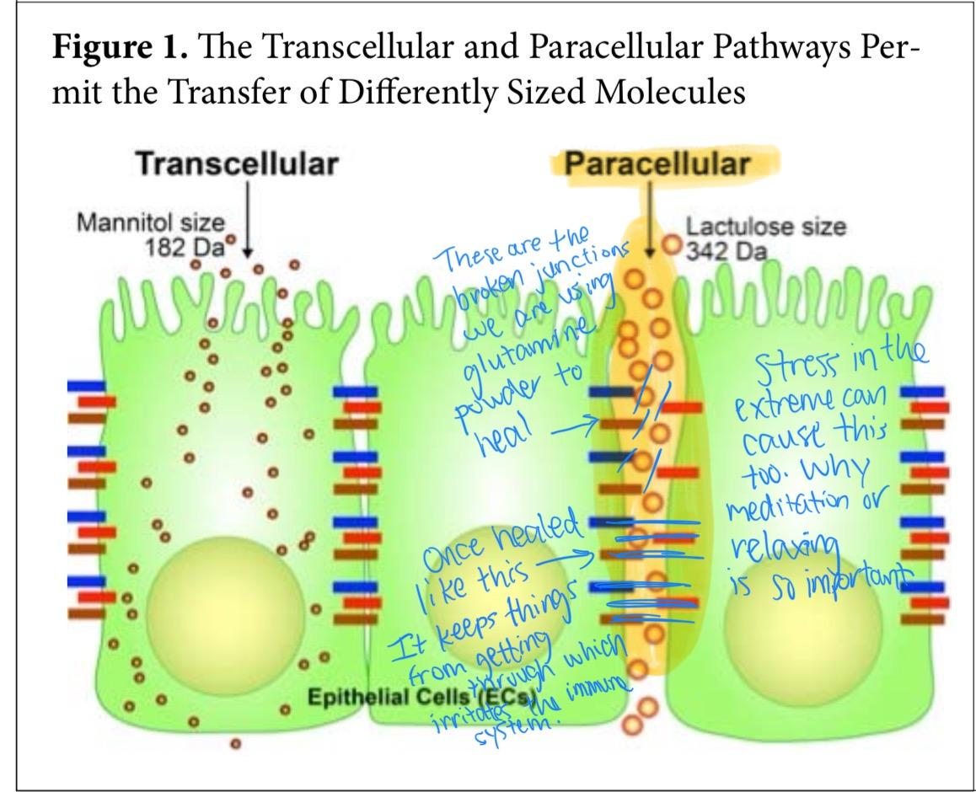
Cyrex results
- Glutenin 21-mer IgG
  - Function: Glutenin or Glutenine is a wheat protein that together with gliadin produces gluten. Glutenin gives firmness to bread dough during the kneading process by increasing the stability through a 3-dimensional network.
  - When do antibodies appear: Celiac disease1,2,4,5 Dermatitis Herpetiformis1
  - Cross reactions: Dermal elastin,1 Rice globulin,3 anti-Rotavirus IgG6
  - Significance - Glutenin makes up one of the T cell stimulatory gluten peptides found in wheat.4 Wheat Glutenin (like rice globulin) is rich in glycine and glutamic acid or glutamine,3 and like gliadin, Glutenin is insoluble in water.5 However, they differ in that gliadins are alcohol soluble, while Glutenin is broken down by acid or alkaline water. Antibodies IgG and IgA to Glutenin are found in patients with Celiac disease2,4 and IgA antibodies are found in patients with Dermatitis Herpetiformis.1 Studies indicate that there is a reduction in antibodies against Glutenin after implementation of a gluten-free diet.1,5
Indicates Non-Celiac Gluten Sensitivity - Meaning you don’t have Celiac or autoimmune disease related to gluten but you are sensitive. So it will stress the immune system. Need to avoid when you get symptoms of autoimmune or psoriasis gets bad on the skin however you will likely be able to get back to eating some

Cyrex Array 4 Results - No allergens
Cyrex Array 10 results
- Hazelnut, raw + roasted
  - Antigen made from: Raw Hazelnuts (Filberts), one half were dry roasted in the oven for 10 minutes
  - Associated with: Hazelnut immune reactivity
  - Cross reactions: Birch pollen, Carrot, Celery, Fennel, Pomegranate, Peanut, Kiwi, Sesame seeds, Poppy seeds, Coconut, Walnut, Pecan1-4
  - Significance – N/A
- Soy Agglutinin
  - Antigen made from: Soybean Agglutinin (SBA) purchased from antigen supplier
  - Associated with: Soybean Agglutinin immune reactivity
  - Cross reactions: Anti-B. Burgdorferi antibodies, Islet Cell
  - Significance – Soybean agglutinins are lectins found in a variety of food stuffs including legumes. Lectins are carbohydrate binding proteins in plants and are important as physiologically active ingredients. Studies on food immune reactivities predominantly use raw food antigens. However, some researchers have noted that heating or combining food proteins can change their antigenicity.3-5
    - This array tests for IgG and IgA food immune reactivity.6,7 Equivocal or out-of-range results indicate antibody reactivity to the tested food antigen. We tested 288 blood donor sera against soybean agglutinin antigens at optimal dilution, 12.5% of these donors were IgG and IgA reactive.

